Advanced Institute of Education, Palwal
Details of Teaching Faculty Session 2021-22
Sr. No | Name | Designation | Qualification | Pay Scale | D.O.J | Photograph
1 | Prof. Laxmi Sharma | Principal  Professor(M.Ed) | M.Sc. (Zoology), M.Ed. (Gold Medalist)  NET-JRF (Education),  Ph.D (Education) | 37400-67000+AGP10000 | 1/09/2007 | 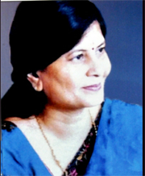
2 | Ms. Geeta Harsana | Assistant Professor | M.Sc (Botany), M.Ed., NET (Education) | 15600-6000AGP-39100 | 16/9/2009 | 
3 | Ms. Komal Sharma | Assistant Professor | M.A (English, Psychology), M.Ed., NET (Education)  Ph.D (Pursuing) (JMIU, Delhi) | 15600-6000AGP-39100 | 2/11/2011 | 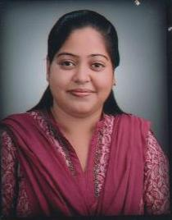
4 | Mr. Manoj Kumar | Assistant Professor | M.A (English), M.Ed., NET (Education) | 15600-6000AGP-39100 | 1/09/2012 | 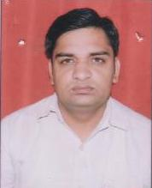
5 | Mr. Surendra Pratap Singh | Assistant Professor | M.A (Pol Science), History, M.Ed.,  NET(Education) | 15600-6000AGP-39100 | 02/08/2017 | 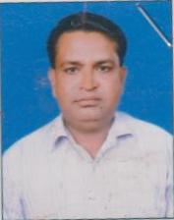
6 | Ms. Madhu Hans | Assistant Professor | M.A. English, M.Ed., M.Phil. (Edu), NET (Edu) | 15600-6000AGP-39100 | 1/10/2018 | 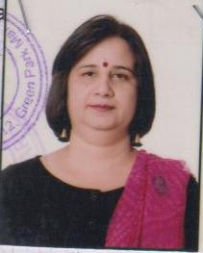
7 | Dr. Kritika Mishra | Assistant Professor | M.Sc., M.Ed. NET (Education), Ph.D. (Education) | 15600-6000AGP-39100 | 1/2/2018 | 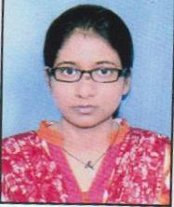
8 | Ms. Ruchika Sharma | Assistant Professor | M.Sc. Math, M.Ed. | 15600-6000AGP-39100 | 07/10/2016 | 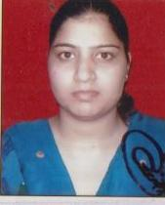
09 | Ms. Sushma Rani | Assistant Professor | M.A. Political Science, M.Ed. | 15600-6000AGP-39100 | 16/01/2019 | 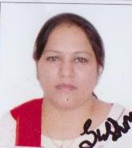
10 | Ms. Poonam | Assistant Professor | M.A (Hindi), M.Ed | 15600-6000AGP-39100 | 1/10/2021 | 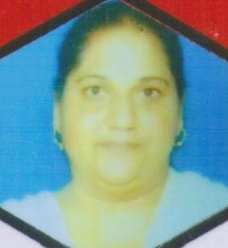
11 | Preeti Bala | Assistant Professor | M.A. (Hindi) M.Ed. | 15600-6000AGP-39100 | 18/09/2018 | 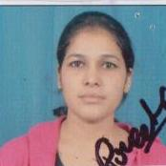
12 | Ms. Saroj Kumari | Assistant Professor | Master of Fine Arts Painting,  NET (Visual Art) | 15600-6000AGP-39100 | 1/2/2023 | 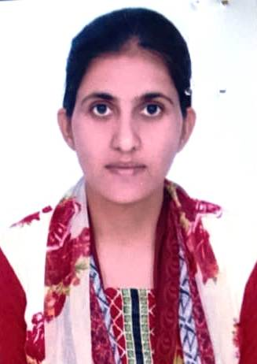
13 | Dr. Kavita Choudhry | Assistant Professor | M.A. (Hindi) M.Ed., M.Phil (Hindi & Education), Ph.D (Hindi) | 15600-6000AGP-39100 | 2/9/2021 | 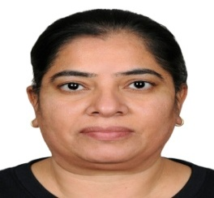
14 | Dr. Raja | Assistant Professor | M.A. (English & History), M.Ed., M.Phil. (English), Ph.D (English) | 15600-6000AGP-39100 | 2/7/2021 | 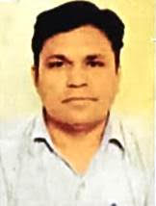
15 | Dr. Sanjay Kumar | Assistant Professor | M.A. (Hindi) M.Ed., M.Phil (Hindi), NET (Hindi) Ph.D (Hindi) | 15600-6000AGP-39100 | 1/2/2023 | 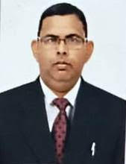
16 | Dr. Jai Devi | Assistant Professor | M.A. (English), M.Ed., NET(Education), Ph.D (Education) | 15600-6000AGP-39100 | 1/2/2023 | 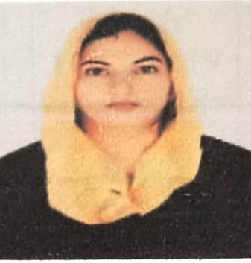
17 | Ms. Rekha | Assistant Professor | M.Com, M.Ed. | 15600-6000AGP-39100 | 5/7/2021 | 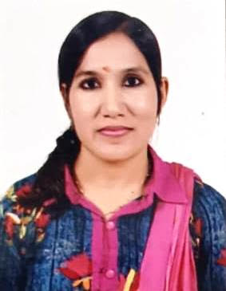
18 | Dr.Binti Dua | Assistant Professor | M.sc (chemistry),  M.Ed., NET(Education), Ph.D (Education) | 15600-6000AGP-39100 | 2/11/2016 | 
19 | Dr.Heena Mittal | Assistant Professor | M.A(Economics),  M.Ed.,  Ph.D (Education | 15600-6000AGP-39100 | 5/7/2021 | 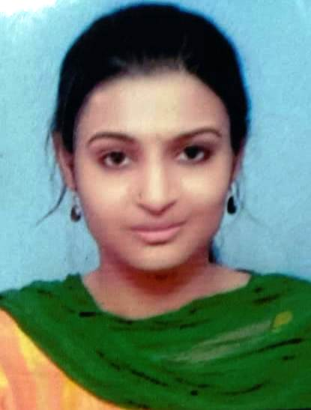
20 | Mr.Manveer | Assistant Professor | M.A(Sanskrit),  M.Ed.,  NET(Education | 15600-6000AGP-39100 | 1/10/2021 | 